Brain Tumor Extraction from MRI images using Prominent Image Segmentation Methods

Shubha Majumder

EE 456: Digital Image Processing, Spring 2018  
Biomedical Engineering

University of North Dakota

*Abstract*— Earlier detection of brain tumors plays a vital role in its treatment as well as dynamically increase the survival rate of the patients. Magnetic Resonance Imaging (MRI) scans are widely used to diagnose the brain tumors which provides better accuracy than other medical imaging techniques. Still, the manual segmentation of MRI images and detecting the brain tumors is a time consuming and prone to error task, which is currently done by the medical experts or radiologists. So, there is an evident necessity for automatic brain tumor segmentation and extracting various characteristics of brain tumors. In this study, three widely used standard image segmentation methods (threshold based, k-means clustering and watershed segmentation) has been tested using collected brain MRI images to isolate the tumors from the rest of the brain regions, and their performance was compared based on the segmentation output. K-means clustering showed a better result than two other methods. Besides this, a graphical user interface (GUI) is designed based on primary image processing techniques and by using the solidity feature of brain tumors. Two of the highly useful brain tumor characteristics (area, and perimeter) are also measured here and displayed on the output window of GUI. The accuracy of this application for tumor detection on brain MRI images and features calculation is much high. More features can be extracted, and the accuracy can be maximized by following some other rigorous techniques, which later could be highly helpful for the medical practitioners working in this field.

***Keywords- Brain tumor, MRI, segmentation, thresholding, k-means clustering, watershed***

# INTRODUCTION

The human brain is a soft and non-replaceable mass of tissue, which is also the control center of the human body. The brain tumor is a collection of tissue which spreads out of control of the forces that regulates the normal growth of body cells [1]. This abnormal growth can occur inside the brain or around the brain, which can actively destroy the healthy brain tissues. It also plays a role to indirectly damage the healthy cells by causing brain swelling, increasing pressure within the skull, and by causing inflammation. It is one of the most common reasons for the increased death rate among children and adults around the world [2]. There are two types of brain tumors based on their severity level, some tumors are cancerous (known as malignant brain tumors), and some brain tumors are not very harmful and do not cause cancer (benign tumors). The National Brain Tumor Foundation (NBTF) of United States estimated that in case of children brain tumor is the reason for one-quarter of all cancer-related deaths. Also, it showed a massive increase in death toll among the people who develop brain tumors [3][2]. There are many imaging technologies used for brain tumor detection. Some of them are Computed Tomography (CT), Magnetic Resonance Imaging (MRI), Ultrasound, X-ray and Positron Emission Tomography (PET) [1]. Among them MRI which uses the pulses of radio wave energy and magnet to build the pictures containing the internal structure of the body and target organs[4]. MRI is widely used since it provides much clear and detailed image than other imaging techniques [5]. It is noninvasive and can be used for any individual ranging from children to adult [1]. However, the radiologists in clinics have to spend about 10-15 minutes for diagnosing one report related to MRI based brain tumor detection. The practice is not only tedious but also there is a risk of errors, which can easily provide wrong information to the patients. On the other hand, automatic detection of brain tumors work much faster, accurate, as well as able to save valuable time [5].

Automatic brain tumor detection from MRI images is an active research field. Many groups all-around the world are working on this problem. Diaz et al. [6] showed an automatic brain tumor segmentation method (ABTS) for segmenting different components of tumors using four MRI image modalities. They achieved a good accuracy for edema and gross tumor volume segmentation. Joshi et al. [7] applied iterative contour detection technique for filtered MRI images, which detected various objects on the images. Then, tumor region was extracted using threshold segmentation method. Liu et al. [8] developed automatic segmentation strategy for metastatic brain tumor detection on contrast-enhanced T1-weighted MRI images. Haeck et al. [9] described an automated brain tumor segmentation method for MRI images; they used an Expectation Maximization-approach to estimate intensity models for brain tissues.

Now, for image analysis segmentation is the process used to divide an image into regions with similar properties such as gray level, texture, color, depth, and contrasts. In case of medical images, segmentation is mainly focused on gray-level values of pixels since most of the medical images are representations of gray-scale [10].The aim of the segmentation, in this case, is to identify the region of interest (ROI), i.e., identifying the tumor, or other abnormalities, as well as measure the growth or change of tumor volume, which later helpful for treatment [11]. Now there are many segmentation methods used for MRI image analysis; thresholding approach, clustering methods, and region growing are some of the commonly used methods. In this study, I worked with three image segmentation algorithms which are thresholding using Otsu method, K-means clustering, and watershed segmentation. Later an easy to use Graphical User Interface (GUI) is built to detect the tumor on the brain image based on solidity, and tumor features (Area, Perimeter) are calculated and displayed on it.

# Image segmentation methods

MRI image segmentation process can be roughly separated into two categories, single or gray image segmentation, where a 2D or 3D image is used for segmentation, and another is multi-spectral segmentation, where an image with different grayscale contrasts are used [12].The segmentation methods I used are discussed below.

## Threshold Based Segmentation

Threshold-based segmentation is regarded as the most straightforward image segmentation technique which separated the image directly into sections based on intensity values[13]. Thresholding can be divided into local or global thresholding based on the number of threshold values selected for a particular image [14]. Segmentation of an image which has more than two type of regions corresponding to several types of objects known as local thresholding method [15]. In case of intensity images, light objects over the dark background are segmented by using a specific threshold value. The pixels which are above the specified threshold value are denoted as 1, and on the other hand, the pixels which are less than this value are regarded as 0. So, for any image I (i, j) the segmented image S (i,j) is

$$S\left(i,j\right)=\left\{\begin{aligned}0, &I(i,j)<Threshold \\ 1, &I(i,j)≥Threshold\end{aligned}\right.$$

Here 1 valued pixels are representing the region of interest (ROI), and 0 valued pixels are used for background [14]. The advantage of threshold technique is; it is useful for image linearization which is essential for any segmentation. Though some groups reported thresholding using Otsu’s method is more suitable for segmenting brain tumors from MRI images [10], the disadvantages are that this technique is not useful for all types of MRI images, which occurs due to the huge variation of image intensity on background and foreground of an image [3].

## Watershed Segmentation

Watershed, which is a geological term used to designate a narrow, hilly area that separate two entities of water, or rivers known as catchment basin [16]. For image processing, grouping of pixels using their intensity values is another definition of watershed segmentation [17]. This transform is a morphological gradient-based segmentation method. The gradient map of a particular image is regarded as relief map in which various gradient values represents various heights. If a hole is punched in each local minimum and then immerse the map in water, the level of the water will rise over the basins. When two different bodies of water meet each other, a dam is built to separate them. The process continues till all the points of the map are occupied. In the end, the whole image is segmented by the watersheds and the segmented regions are denoted as catchment basins [18]. It is a widely used method and good for grouping pixels based on their intensities. The main disadvantage of this method is its sensitivity to intensity variations, which result in over-segmentation. The over segmentation problem still exists for this method [3].

## K-Means Clustering

The K-Means Clustering is mostly used and studied method among the clustering formulations that are based on minimizing a formal objective function [19]. It is a key technique in pixel-based methods. Because, pixel-based methods founded on K-means clustering are relatively simple and have less computational complexity than other region-based or edge-based methods, as well as the application is practicable [20]. It is an unsupervised clustering method which classifies the inputs into several groups based on their inherent distance from each other [21]. Moreover, K-means clustering is a suitable method for biomedical image segmentation since the total number of clusters is usually known for images of specific regions of the human body [20]. Due to its quick runtime, smooth implementation and better image segmentation, it can be used for real-time segmentation application [3].

# Methodology

In this study, the MRI images with brain tumors are acquired from various internet sources, which are then used for brain tumor detection using three above mentioned segmentation methods. The output of the three methods is compared to choose the preferable one. Finally, a Graphical User Interface (GUI) is designed to make it easy for the user to detect the tumor from a given input image. The GUI is also used to show some of the measured parameters of the tumors like area and perimeter of the detected tumors, which are very useful indicator for overall size and severity determination. The described methodology was followed for tumor segmentation and tumor extraction. The steps are as follows:

1. Read brain MRI images
2. Preprocessing for noise removal and increase reliability of the images for further processing.
3. Apply different image segmentation methods
4. Monitoring segmented brain tumors for each method
5. Extract the useful features of the segmented tumor
6. Show the detected tumor and the tumor parameters on the GUI output.

## Preprocessing

The key purpose of preprocessing is to remove the noises from the MRI image and make it more useful for the rest stages of the whole process. Different kind of filters like averaging filter, median filter, Gaussian smoothing, and Wiener filter has been applied in this regard. Among them, Median filter and Wiener filters showed better performance than others, and these are used for the rest of the processing steps. The advantage of the Median filter is that it can remove the high-frequency components in the MRI images, also advantageous for removing noises without disturbing the edges [3].

## Image Segmentation and Tumor Extraction

After denoising the images, the segmentation algorithms are applied, which are thresholding using Otsu’s method, K-means clustering, and watershed segmentation.

*B1. Otsu Thresholding*

Otsu’s thresholding is a clustering oriented segmentation method which converts the grayscale image to a binary image by assuming that the image only has two types of pixels, one is foreground pixels, and another is background pixels. Threshold values were selected for specific images, and that were used to covert the images to binary images. The morphological operation was done which operated the morphological opening then the output was subtracted from the original image. Image enhancement was done and others small objects were removed to show the segmented tumor.

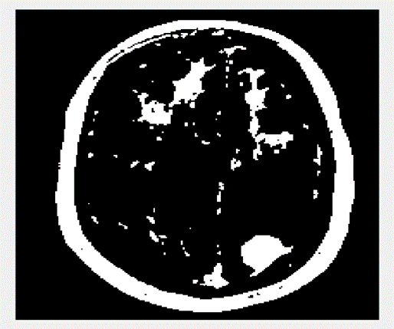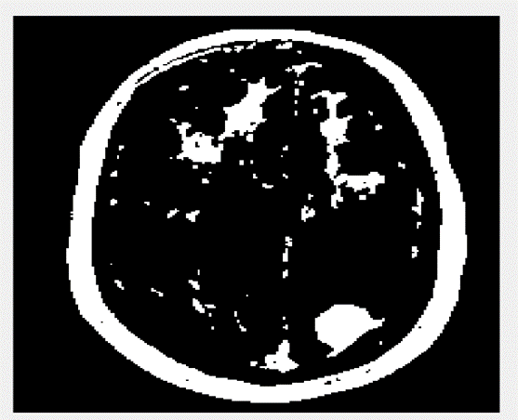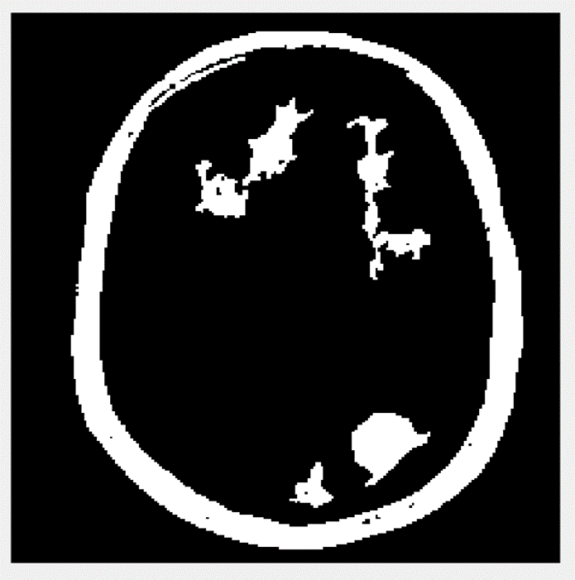

(a) (b) (c) (d)

Fig 1: a) Binary image after thresholding, b) After morphological operation c) After removal of small objects and d) the segmented brain tumor

This method is sometimes unable to detect the tumors accurately, sometimes a portion of a tumor or the skull portion is also misinterpreted as the brain tumor, as well as the displayed regions are dependent on threshold values.

*B2. K-means clustering*

In case of K-means clustering, the initial set of clusters (K) need to be defined since the segmentation process is dependent on the value of K or number of clusters. In this study, the value of K is selected as 4, since the human brain images with tumor can be clustered into 4 clusters, where our targeted tumor belongs to one of the clusters (here in cluster 3). At first, the image was converted to linear space, and then the ‘k-means’ algorithm was applied, which generated a set of clusters and cluster centroids [22]. The linear space image is then reconverted to the spatial domain. After that, the tumor was extracted from the cluster 3 by applying morphological operations.

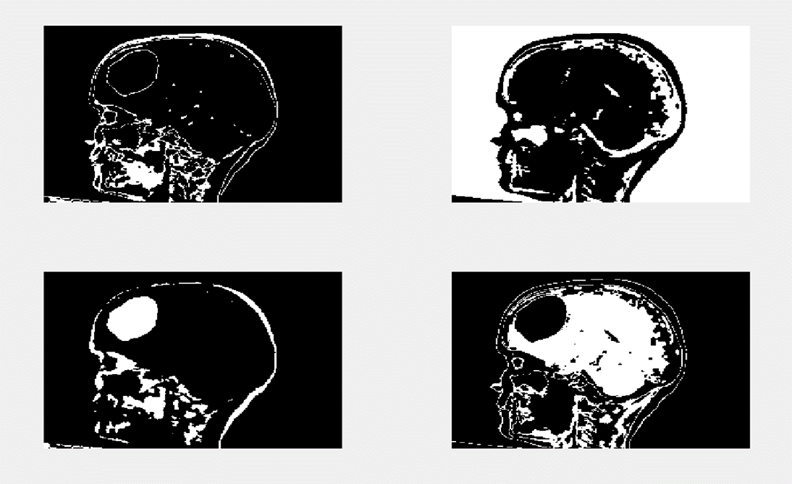

(a)

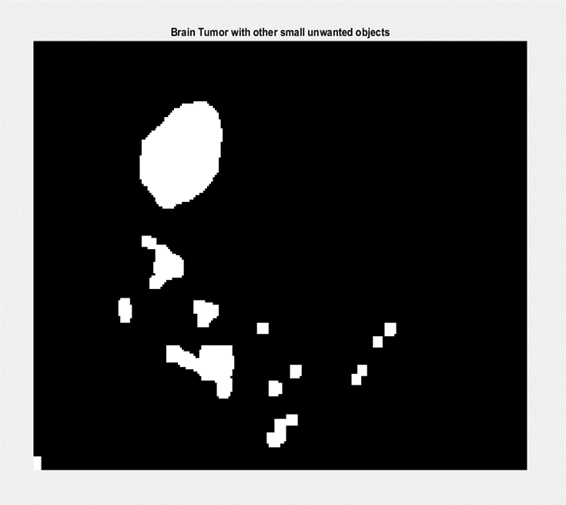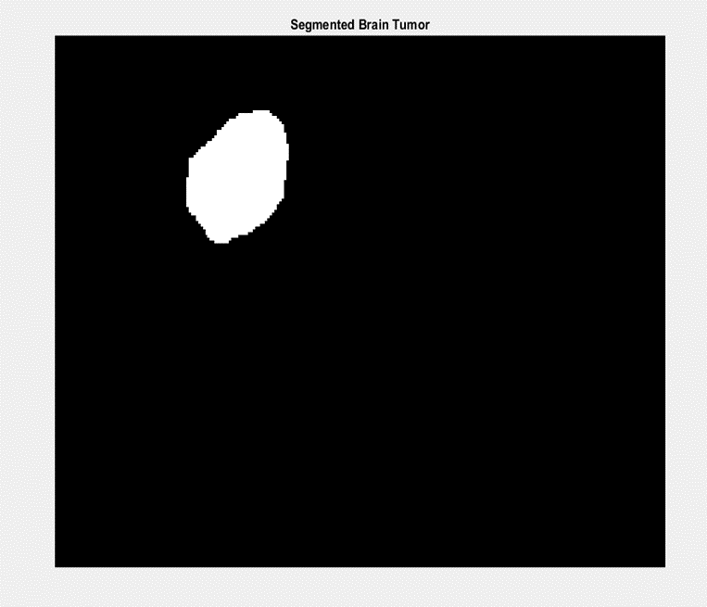

(b) (c)

Fig 2: a) 4 clusters after applying K-means algorithm, b) Brian tumor with other small objects, and c) Segmented tumor.

*B3. Watershed Segmentation*

Watershed segmentation technique is highly useful when the targeted objects are in touching position. At first, necessary steps are followed like preprocessing, morphological operations, image enhancement, image binarization and erosion using a specific disk-shaped structural element. The complement of the eroded image has been taken, and distance transform was applied after which the bright catchment basins were determined by taking the negative of the distance transform. The watershed algorithm was applied which returned a labeled matrix comprises of positive values along the catchment basins. After that, to get the ultimate segmented output, the labeled matrix was converted to an RGB image.

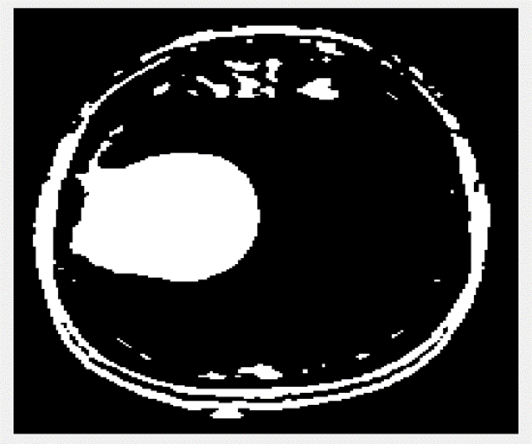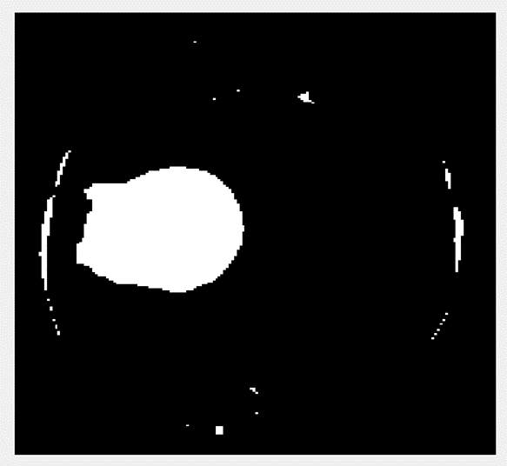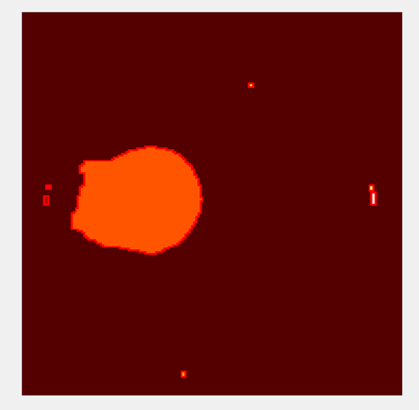

(a) (b) (c)

Fig 3: a) Initial Binarized image, b) Eroded image and c) Detected brain tumor.

## Graphical User Interface for Tumor Detection

After applying all these segmentation methods, a graphical user interface (GUI) was designed for general usability of the overall process, where the solidity of the tumor was focused since the solidity of the brain tumor is high enough compared to normal brain tissues. The application can detect the brain tumors with good accuracy, and it is effortless to use. Moreover, some other characteristics of the tumor are calculated (Area, and Perimeter) and displayed in the GUI output window. Other useful parameters also can be calculated in this way.

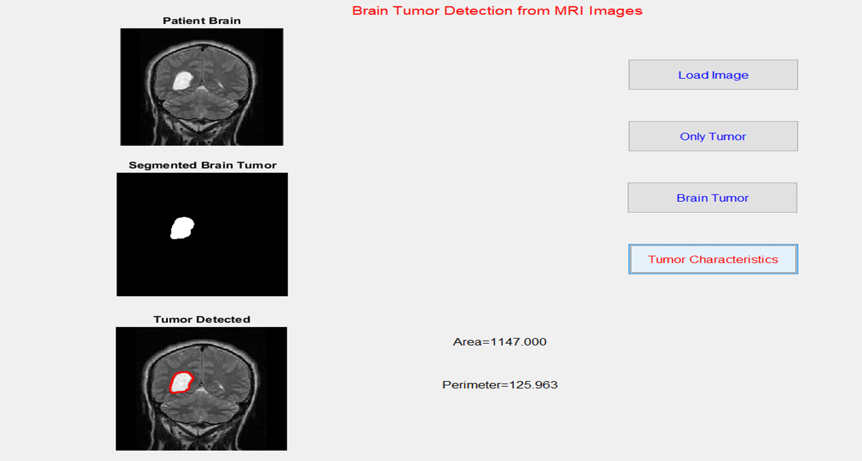

Fig 4: Graphical User Interface with the input image, segmented tumor and other characteristics of a brain tumor.

# Discussion

The segmentation methods, tumor detection, and GUI design has been implemented by using MATLAB (R2015a). The MRI images have been collected from different online sources, and all of the used images are 2D image. The work compared three well-known gray-scale segmentation techniques for brain tumor detection and a tumor solidity based GUI was made for easy tumor detection and features extraction.

# Future Directions and Conclusion

An application for automatic brain tumor detection is presented here. After preprocessing of the MRI 2D images Otsu’s thresholding, k-means clustering and watershed segmentation methods were applied, and their performance was compared. In this study, K-means clustering performed better than other two segmentation methods, where watershed segmentation method was prone to misdetection for the used images. The GUI designed here based on the solidity of brain tumor is a useful user interface. It can detect the tumor with a high accuracy level, and by varying the threshold solidity level, it is possible to detect more early-stage brain tumors. Two useful tumor parameters (area and perimeter) are calculated in this study which can be increased in number by adding some other techniques with the current algorithm, which will be helpful for the expert to decide more precisely about the current situation of the patients as well as will be useful for brain tumor treatment.

# References

[1] W.-C. Lin, E. C.-K. Tsao, and C.-T. Chen, “Constraint Satisfaction Neural Networks for Image Segmentation,” in *Artificial Neural Networks*, Elsevier, 1991, pp. 1087–1090.

[2] T. Logeswari and M. Karnan, “An Improved Implementation of Brain Tumor Detection Using Segmentation Based on Hierarchical Self Organizing Map,” *Int. J. Comput. Theory Eng.*, vol. 2, no. 4, pp. 591–595, 2010.

[3] E.-S. A. El-Dahshan, H. M. Mohsen, K. Revett, and A.-B. M. Salem, “Computer-aided diagnosis of human brain tumor through MRI: A survey and a new algorithm,” *Expert Syst. Appl.*, vol. 41, no. 11, pp. 5526–5545, 2014.

[4] I. Conference, S. G. Development, B. Vidyapeeth, C. Applications, and N. Delhi, “Review of Brain Tumor Detection from MRI Images,” pp. 3997–4000, 2016.

[5] A. Sehgal, S. Goel, P. Mangipudi, A. Mehra, and D. Tyagi, “Automatic Brain Tumor Segmentation And Extraction In MR Images,” pp. 104–107, 2016.

[6] I. Diaz, P. Boulanger, R. Greiner, B. Hoehn, L. Rowe, and A. Murtha, “An automatic brain tumor segmentation tool,” *Proc. Annu. Int. Conf. IEEE Eng. Med. Biol. Soc. EMBS*, pp. 3339–3342, 2013.

[7] A. Joshi, “A Novel methodology for brain tumor detection based on two stage segmentation of MRI images,” 2015.

[8] Y. Liu *et al.*, “Automatic metastatic brain tumor segmentation for stereotactic radiosurgery applications.”

[9] F. Maes, “An Untrained and Unsupervised Method for MRI Brain Tumor Detection", Medical Imaging Research Center , Leuven , Belgium iMinds - Medical Information Technologies , Belgium,” *Isbi*, pp. 265–268, 2016.

[10] G. M. N. R. . Gajanayake, R. D. . Yapa, and B. Hewawithana, “Comparison of standard image segmentation methods for segmentation of brain tumors from 2D MR Images,” *… Inf. Syst. …*, no. December, pp. 28–31, 2009.

[11] P. B. Kanade and P. P. Gumaste, “Brain Tumor Detection Using MRI Images,” *Ijireeice*, vol. 3, no. 2, pp. 146–150, 2015.

[12] L. P. Clarke *et al.*, “MRI Segmentation : Methods and Applications,” *Pergamon l Rev. Magn. Reson. Imaging*, vol. 13, no. 3, pp. 343–368, 1995.

[13] R. N. Strickland, “Image-Processing Techniques for Tumor Detection.”

[14] M. A. Qadar and Y. Zhaowen, “Brain Tumor Segmentation : A Comparative Analysis.”

[15] N. Gordillo, E. Montseny, and P. Sobrevilla, “State of the art survey on MRI brain tumor segmentation,” *Magn. Reson. Imaging*, vol. 31, no. 8, pp. 1426–1438, Oct. 2013.

[16] Rafael C. Gonzalez and Richard E. Woods, “Digital Image Processing:2nd (Second) edition”.

[17] A. Mustaqeem, A. Javed, and T. Fatima, “An Efficient Brain Tumor Detection Algorithm Using Watershed &amp; Thresholding Based Segmentation,” *Int. J. Image, Graph. Signal Process.*, vol. 4, no. 10, pp. 34–39, 2012.

[18] N. Li, M. Liu, and Y. Li, “Image Segmentation Algorithm using Watershed Transform and Level Set Method,” *2007 IEEE Int. Conf. Acoust. Speech Signal Process. - ICASSP ’07*, p. I-613-I-616, 2007.

[19] J. Vijay and J. Subhashini, “An efficient brain tumor detection methodology using K-means clustering algoriftnn,” *2013 Int. Conf. Commun. Signal Process.*, pp. 653–657, 2013.

[20] M. Wu and C. Lin, “Brain Tumor Detection Using Color-Based K-Means Clustering Segmentation,” pp. 3–6.

[21] S. Murugavalli and V. Rajamani, “An Improved Implementation of Brain Tumor Detection Using Segmentation Based on Neuro Fuzzy Technique,” *J. Comput. Sci.*, vol. 3, no. 11, pp. 841–846, 2007.

[22] A. S. Murali, "Brain Tumor Segmentation from MRI Images”.